$$x$$ | 1 | 2 | 3 | 4
$$y$$ | -3 | -1 | 1 | 3
$$x$$ | -1 | 0 | 1 | 2
$$y$$ | 2 | 2.5 | 3 | 3.5
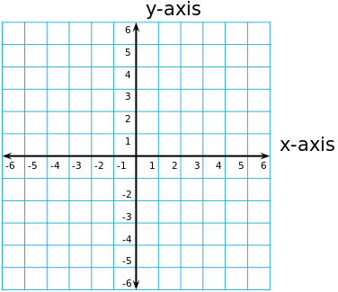


$$x$$ | -3 | -2 | -1 | 0
$$y$$ | -5 | -2 | 1 | 4
$$x$$ | -4 | -2 | 0 | 2
$$y$$ | 2 | 0 | -2 | -4




